# Essentials of Statistics and Math for Data Science - Project 3

**Part A**

Six different machines are being considered for use in manufacturing rubber seals. The machines are being compared with respect to tensile strength of the product. A random sample of four seals from each machine is used to determine whether the mean tensile strength varies from machine to machine. In the Data.xlsx (Sheet Part A) file you find the tensile-strength measurements in kilograms per square centimeter.

Perform the analysis of variance at the 0.05 level of significance and indicate whether or not the mean tensile strengths differ significantly for the six machines.

**Solution:**

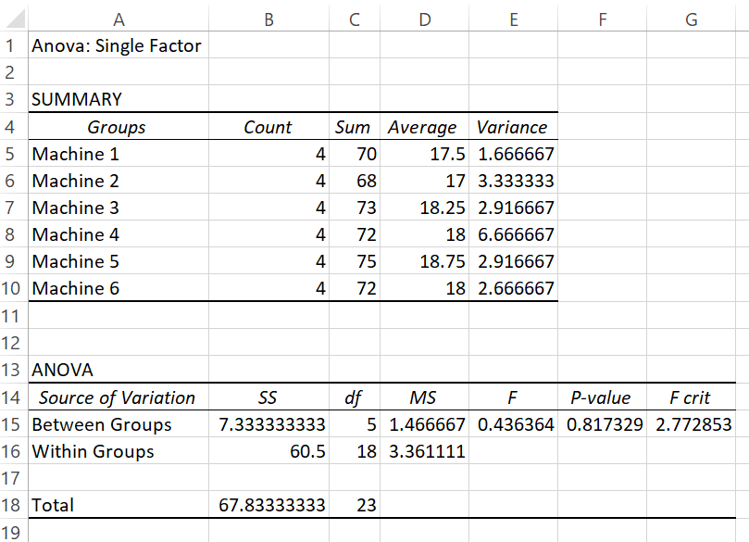

**Part B**

Please refer to the file Data.xlsx (Sheet Part A) for this part. A study measured the sorption (either absorption or adsorption) rates of three different types of organic chemical solvents. These solvents are used to clean industrial fabricated metal parts and are potentially hazardous waste. Independent samples from each type of solvent were tested, and their sorption rates were recorded as a mole percentage. Is there a significant difference in the mean sorption rates for the three solvents? Use a P-value for your conclusions. Which solvent would you use?

**Solution:**

